Oak Grove Men’s Tennis
Coach Bestor Email: thomasbestor@davidson.k12.nc.us Room:1214
Workouts: 2/15- 2/17 & 2/22-2/24 (4-5:30)
FIRST PRACTICE | Mar 4, 2021
FIRST CONTEST | Mar 15, 2021
LAST CONTEST | Apr 30, 2021
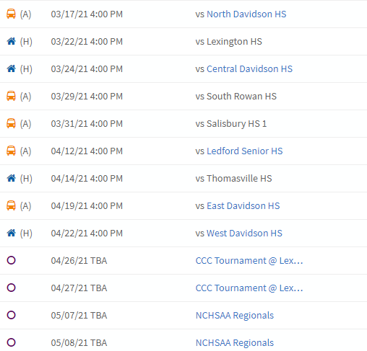
Remind: Text to 81010
@749hh

